Using Google to search for PowerPoint shows

Someone somewhere has already written a PowerPoint show about a topic that you want to teach. That someone has also posted the show to the Internet so you can download it and use it in your class. Now, all you have to do is find the show!

Go to http://www.google.com/ and select Advanced Search.



Step 1 – Enter a short phrase in one of the white search boxes.

Step 2 – In the file Format section select Microsoft PowerPoint.

Step 3 – Click Google Search.

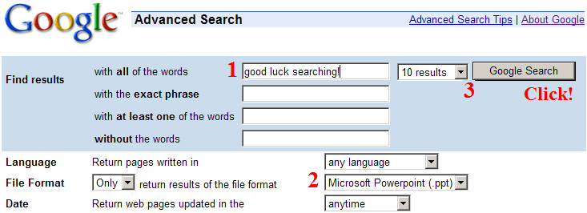

Download the show. Save it to your computer. Give credit to the original author when you use their great shows in your class. Edit the show if needed, but do not post the show back on the web as your work!

