
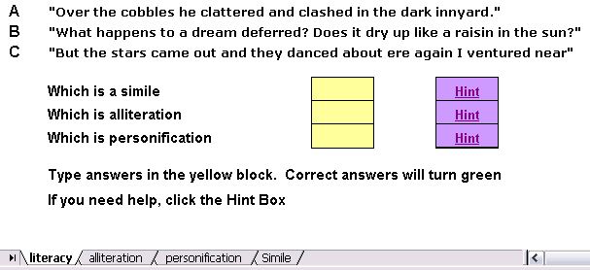
Using Conditional Formatting for Literacy Practice

The picture above shows what an Excel worksheet would look like for the activity described below.

Open an Excel Workbook.

Step One - Click in cell B2 and type in the literary technique example. Place your cursor between the letters B and C at the top of the columns. Double click when you cursor turns into a black 2 sided arrow with a line down the middle to make the cell bigger.

Step Two – Now type in a literary technique example in cell B4 and then in cell B6.
Step Three – In Cell A2, type the letter A; in Cell A4, type in a B, and in cell A6, type in a C.

Step Four - The next thing to do is to format all of the writing. Highlight from cell A2 to B6. An easy way to do this is to click on cell A2 one time. Next, hold down your shift key and click on cell B6. Everything between the clicks will be highlighted.
Step Five – Using the Toolbar, you can select the font you wish. I would also select the Center button and the B button (for Bold) to make the print stand out.

Step Six - Click in cell B9 and type the words Which is a simile? (or your chosen literary technique). In cell B10 type Which is personification? and in cell B11 type Which is alliteration? Again, double click between the letters B and C on the top of the column to make the words fit into the cell.

Step Seven - Click in cell B9 and drag down to cell B11 to select all three cells. Use the font size block on the Formatting toolbar to change them to size 14.

Step Eight - Click in cell D9 and drag to cell D11. Use the Borders button on the Tool bar across the top to draw boxes around all three cells using the All Borders button.
Then, use the Fill Color bucket on the Tool Bar at the top to fill all three cells with light yellow.

Step Nine - - Click and drag to highlight all three of the light yellow boxes. Use the Font Size box to change font size to 16.

Step Ten Click into cell C8 and type, “Type answers in the blocks, correct answers will turn green.”

Step Eleven - Save your work before going further.

Setting conditional formatting in the Answer boxes

Step One - Click into cell D9 (the first light yellow block). Decide if the answer is A, B, or C before going further.

Step Two - Select the Format menu from the top, slide down to Conditional Formatting and click one time.

Step Three - In the Conditional Formatting window use the pull down arrow to make box 2 read equal to and then in the block to the right of that type the letter B (if that is the correct answer on your worksheet). On the right side, click on the button that is labeled Format, and then in the Color block use the pull down to select Bright Green. Click OK to come back to the Formatting window, but do not click on the Conditional Formatting window yet. Next choose Add (the leftmost button on the last row) and this time make the cell contents not equal to. Enter B just as you did before. Next Click on the Format button and change the color to red.

Step Four - Move to cell D10 and continue the same process until conditional formatting has been set for cells D10 and D11.

Step Five - Save your work.

Setting hyperlinks for the Hint boxes
Create your Hint sheets and boxes

Step One – On the bottom of your workbook you will see tabs that say Sheet One, Sheet Two, etc. Double click on the words Sheet One and rename it Literacy. Double click on the words Sheet Two and rename it alliteration. Name the other sheets. If you need more sheets, hold down the Shift key and press the F11 key one time for each sheet. Rename all of the sheets you need.

Step Two – Click on each tab you have renamed and then click on cell A3. Write a description of the technique and maybe an example of how it is used so the student will understand the meaning. Click on cell A1. Write the word Back and press enter. Right click on the word Back and click on Hyperlink. On the left hand side, click on the words Place in this Document. You will see the sheets you have. Click on the sheet name that will go back to the main literacy page. Then click OK. Do this for all the tabs.

Step Three - - -Click in cell F9 and drag down to cell F11 to select all three cells. Use the Borders button on the Tool bar across the top to draw boxes around all three cells using the All Borders button. Then, use the Fill Color bucket on the Tool Bar at the top to fill all three cells with light purple. (or a color of your choice

Step Four. Click in cell F9 and type the word Hint. Do the same for F10 and F11

Step Five Right Click in cell F9 and click on the word Hyperlink. On the left hand side, click on the words Place in this Document. You will see the sheets you have. Click on the sheet name that matches the hint for that technique. Then click OK. The word Hint will now have a blue line under it indicating that is a link. Do the same for the other technique hints. Save your work.

