Making a Timeline in Excel

In this activity you will make a timeline using AutoShapes in Excel. The grid lines will be hidden by a color. Your final product will resemble the timeline below.
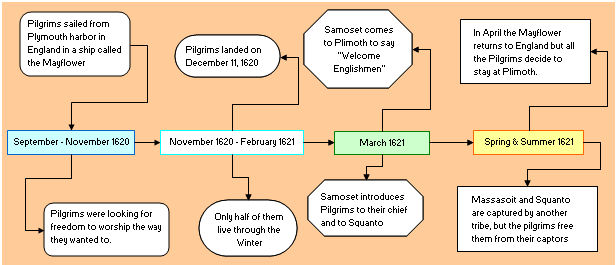

Your first task will be to collect 2 facts from each of the first 4 time periods at the following web site below:
http://teacher.scholastic.com/thanksgiving/pictimeline/sep1620.htm
Record your facts in the table.
Pilgrims’ first year in America
Sept-Nov 1620 | Nov 1620 – Feb 1621
March 1621 | Spring & Summer 1621

Step-by-step directions for using Excel to make a timeline

- Launch MS Excel. Click on the Start button (bottom left), move the mouse pointer up to programs and click, slide to the right to find Excel or MS Office, Click on Excel
- We will leave the grid lines in place until the time blocks are placed on your worksheet.
- Is the Draw menu located below your worksheet? If so, go to step 5.
- If not, click on the View menu, select Toolbars, and then slide over and down to click on Drawing.
- In the Drawing toolbar you will see the word AutoShapes. This is where you select shapes to use in your concept map.
- Click on AutoShapes, move your mouse pointer up to Basic Shapes, then slide over and down to the rectangle (first one on the first row). Click one time.
- Clicking does not make a shape; it gives you the cross-hair cursor with which you will draw a shape.
- Start near the middle row of cells and click and drag to draw a rectangle as long and as high as two cells. The shape should be surrounded by circles indicating that it is selected.
- Next you will copy the shape you just drew. Depress the Ctrl key and tap on the C key one time; this copies the selected item.
- Without letting go of the Ctrl key, tap the V key three (3) times. This process pastes the selected item three times, each one on top of the other, displaced slightly downward diagonally.
- Move the rectangles so they form a line from left to right. Allow a one cell space between each rectangle.
- Starting with the leftmost block, enter the four time periods in the rectangles. Click in a block and start typing. You can draw the block wider if you need more space.
- Click on AutoShapes, move your mouse pointer up to Basic Shapes, then slide over and down to the Rounded Rectangle (first one on the second row). Click one time.
- Draw a Rounded Rectangle as you did in step 8 above.
- Copy the shape then paste seven (7) more of them as you did in step 10 above.
- Move the shapes placing one above each time block and one below.
- To cover the gridlines, click in any cell (not on an AutoShape), select all cells by holding down the Ctrl key and tapping one time on the A key.
- To fill a color on the sheet, locate the paint bucket on the formatting toolbar. Click on the down arrow to see available colors. Click on a color to fill the worksheet (but not the AutoShapes) with that color.
- Click in the empty AutoShapes and enter the facts you collected. Drag a shape wider to allow more room for the text you enter.
- It is time to connect the rectangles on your concept map. Click on AutoShapes, move your mouse pointer up to Connectors and select one with an arrow on one end.
- Move your cursor to a rectangle, but do not click yet. Let your mouse pointer hover over the rectangle and you will see blue dots pop up on the shape. Click on one and let up on the mouse button.
- Do not click and drag. Move your cursor to the shape you want to connect the first one and hover over the shape until you see the blue dots. Click on the dot to make a connection.
- If the dots at both ends turn red, the connection is locked.
- If one dot is green, click on the green dot and drag it to one of the blue dots. When it turns red, let go of the mouse button.
- Continue this process until all connections are made.
- If you wish to change the color of an AutoShape, right click on the edge of the shape, select Format AutoShape, and then select the color you want.
- You can format the lines of your connectors by right clicking on the line and selecting Format AutoShape.
- Save your work.

