


TCAP Formatting - Time Lines

You will use an Excel workbook to create a timeline review activity. These can be printed, or can be displayed if you have classroom projection capability.

Open an Excel workbook. First, let’s remove the grid lines before we draw the timeline. Go to the Tools menu, slide down to Options and click one time. On the View tab, in the bottom left corner there is a checkmark by the word Gridlines. Click in the box to remove the check mark and then click OK to return to a blank worksheet. Here is an example of a timeline we will produce.

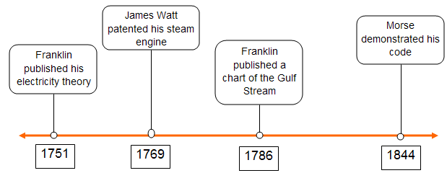

To make the time line, first we will draw one long thick horizontal line with arrows on both ends; you must have the Drawing toolbar open to draw this line. If the toolbar is not open, go to the View menu, select Toolbars and slide over to Drawing and click one time.

Click on the word AutoShapes in the Drawing toolbar, move your cursor to Lines and click one time on the line with two arrow heads. Somewhere near the middle of the sheet on the left side, click and drag to draw a straight line. To make a straight line, hold the shift key down as you draw. Draw the line across most of the sheet. While the line is still selected, move your cursor to the Line Style button on the Drawing toolbar and select the thick line labeled 3 pt. After making the line thicker, use the line color button shaped like a paint brush to color it orange. There is a small down pointing triangle to the right of the button. Click on that triangle to select a color.

For this timeline you will need to draw; four small white circles to mark the place on the timeline, four rectangles to enter dates, and four rounded rectangles to enter events. These shapes can all be found in the Basic Shapes section of AutoShapes. The rectangle is the first shape on row one, the rounded rectangle is the first shape on row two and the circle can be drawn with the first shape on row 3.

Draw one rectangle about one inch wide to hold the date in the timeline. To draw, click once on the rectangle in the Autoshape box. Move your cursor back to the blank page and drag diagonally holding the mouse button down until you get the appropriate size. When you let go of the mouse button, the rectangle will be drawn. Draw one rounded rectangles a bit wider to hold the information, and draw one tiny circle to hold the

place on the timeline. The move cursor should cover the circle. Remember to hold down the Shift key as you draw to make a perfect circle.

After drawing one of each of the shapes, copy the shape by first clicking once on it to select it, then holding down the Ctrl key and pressing the C key (Ctrl + C). After a shape is copied, paste three more of the shapes by holding down the Ctrl key and pressing the V key (Ctrl + V) three times for each shape.

We will use the following dates for our timeline: 1751 Franklin published his electricity theory, 1769 James Watt patented his steam engine, 1786 Franklin published a chart of the Gulf Stream, and 1844 Morse demonstrated his code. Type the year in a rectangle and then type the event in a rounded rectangle. To type on a shape, click on the shape and start typing. After typing all four dates, hold down the Shift key and click on each of the other date rectangles to select them all. Use buttons on the Formatting toolbar to change font size and alignment. Follow the same procedure to change font size and alignment in the event shapes (rounded rectangles). After changing the font size, you may need to change the size of the shape.

Move the dates under the timeline to roughly approximate the span of time. Move the circles onto the arrow just above the dates. Move the events above the timeline over the circle for the date of the event. To move a shape with text in it, you must click on the outside edge of the shape. Don’t be concerned if the shapes are not exactly centered over the circles. That will come later.

The next step is to draw lines connecting the event rectangles to the circles on the timeline. To do that, we will use a part of the AutoShapes menu named Connectors. Click on AutoShapes, move your cursor to Connectors and select the first one, a straight line with no arrow head. Your cursor is now a crosshair cursor used for drawing. Without clicking, move your cursor to an event block. Notice that blue dots pop up showing where you may start drawing the connector. Click on the dot at the bottom of the event shape, let go of your mouse (don’t click and drag) and move down to the circle under the event. When you see blue dots click one time on the highest dot on the circle. Don’t be concerned about missing, we can move the connector line later. Also, don’t be concerned if the lines are slanted, we will also straighten them later. Follow this procedure until all four events are connected to the appropriate dots.

Click on the outer edge of one of the event blocks. Pick the one with the most slanted connector line. With the edge of the event block selected, use the keyboard arrow keys to move the block until it is centered over the dot and the connector is straight. Follow this procedure to straighten each of the event blocks.

If you want to move a connector, click on the end that you want to move, and drag it to another spot on the circle.

Sample review questions to use with this timeline:
- In 1759 Halley's comet returned confirmed Newton's mechanics. Where would that event fit on the timeline?
- In 1807 Robert Fulton made a paddle-wheel steamboat. Between what two dates would that event be found? How many years after the steam engine was this event?
- In1853 Alexander Wood introduced the hypodermic syringe, thus making it possible for morphine to be injected to wounded soldiers in the American Civil War. Where would that event fit on the timeline?

